***Java Assignment Questions***

* Write a program that accepts the marks of 5 subjects and finds the sum and percentage marks obtained by the student .

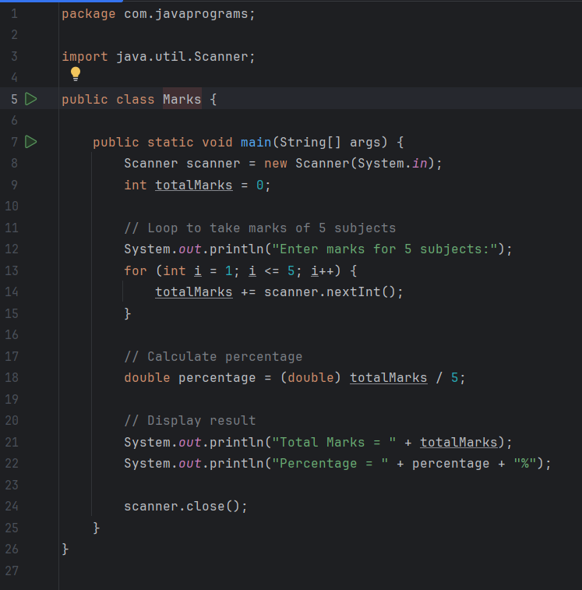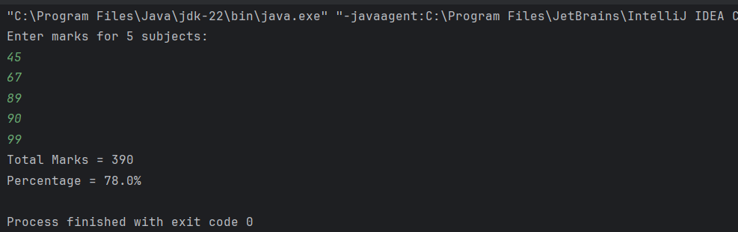

* Write a program that calculates the Simple Interest and Compound Interest. The Principal, Amount, Rate of Interest and Time are entered through the keyboard.

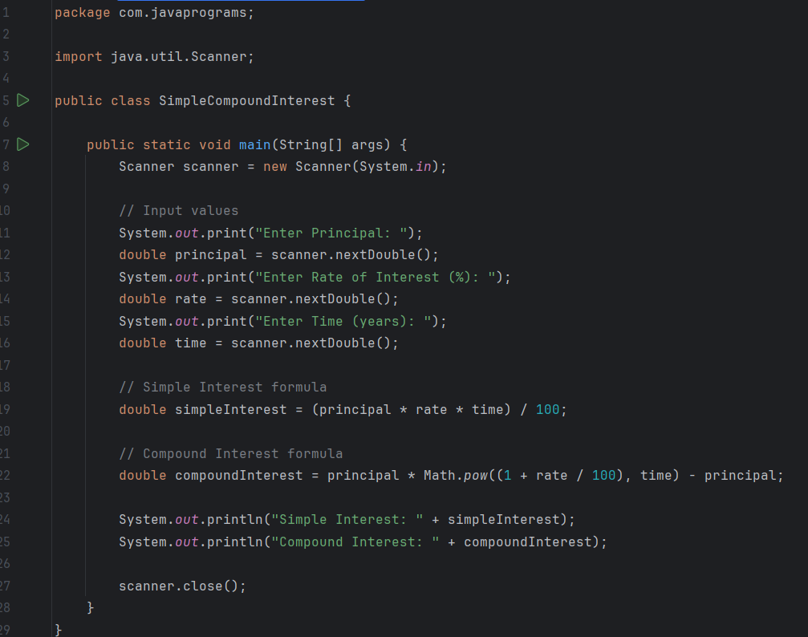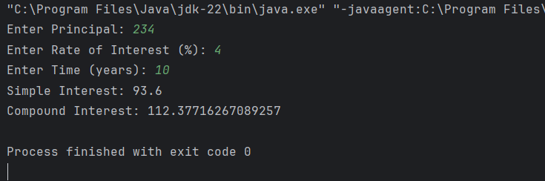

* Write a program to calculate the area and circumference of a circle.

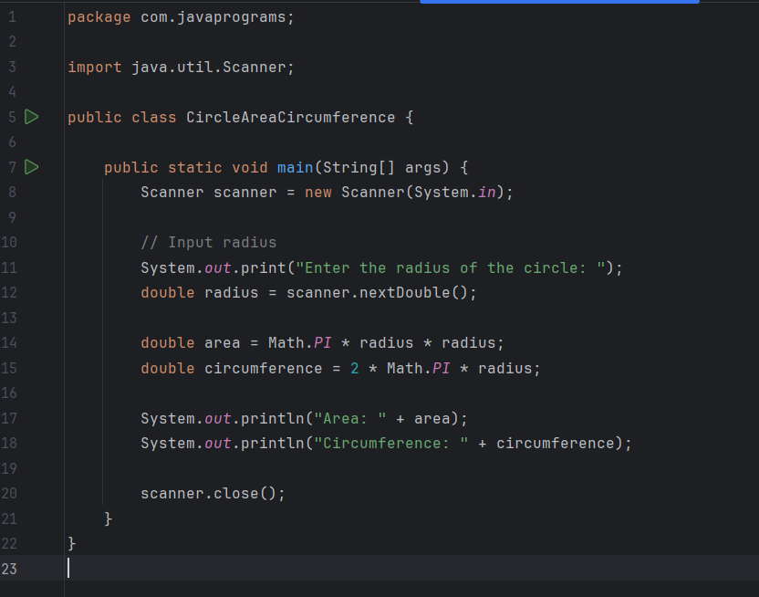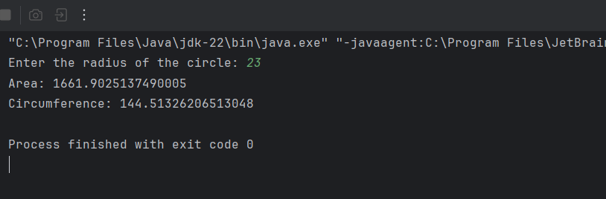

* Write a program that accepts the temperature in Centigrade and converts into Fahrenheit using the formula C/5= (F- 32)/9

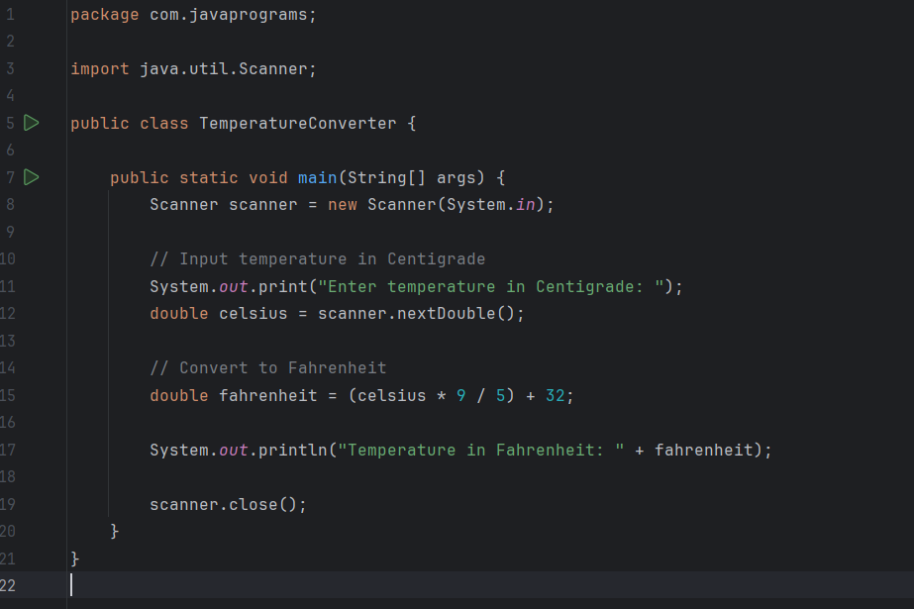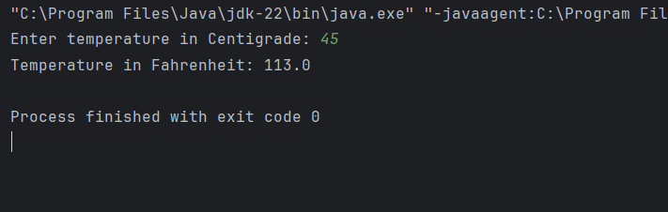

* Write a program that swaps a programs value of two variables using a third variable.

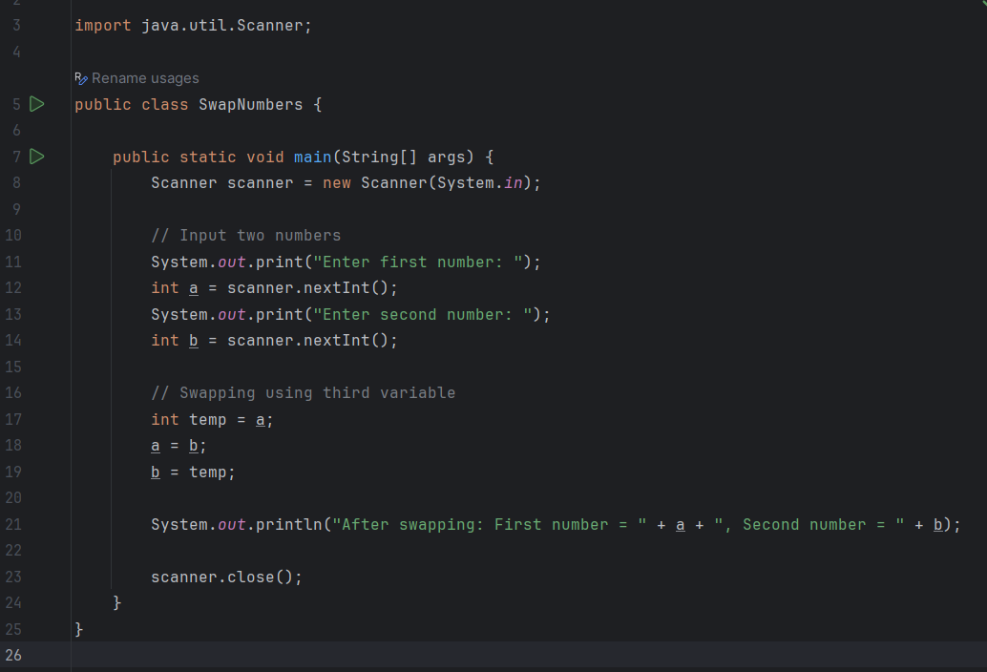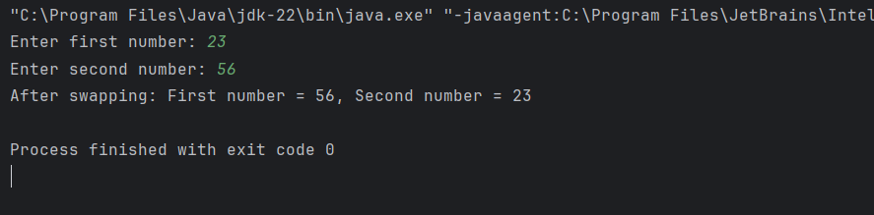

* Write a program that checks whether the two numbers entered by the user are equal or not.

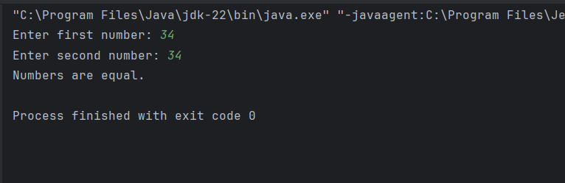



* Write a program to find the greatest of three numbers.

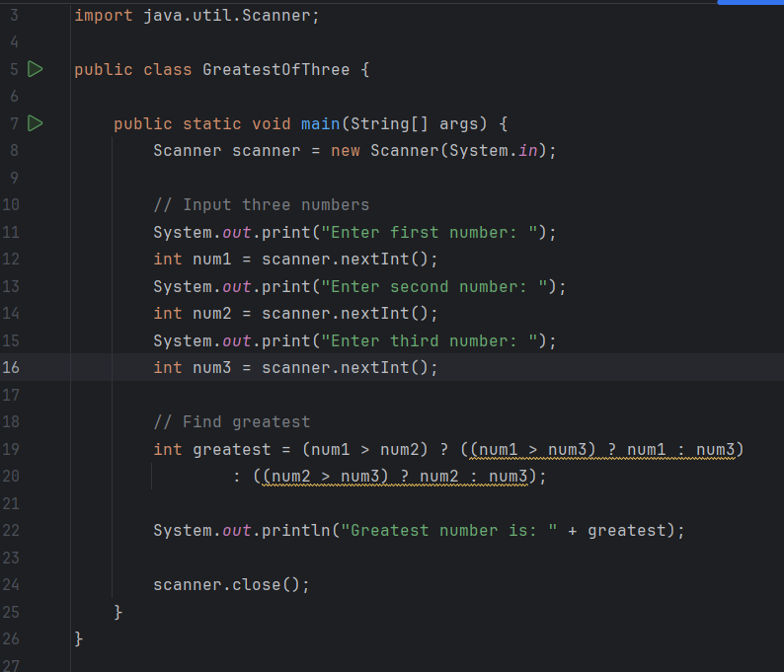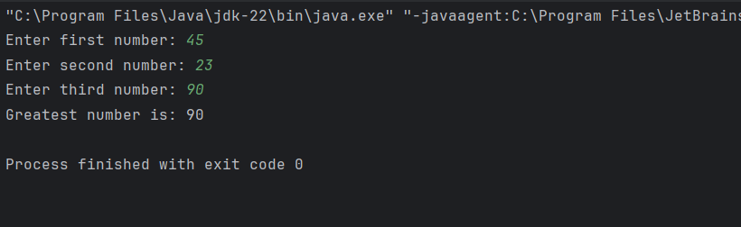

* Write a program that finds whether a given number is even or odd.
* 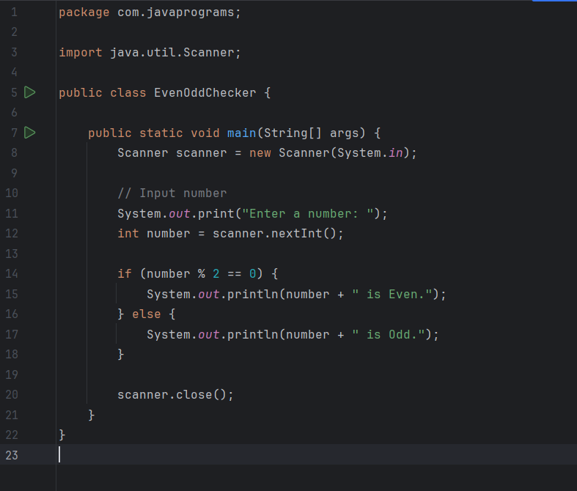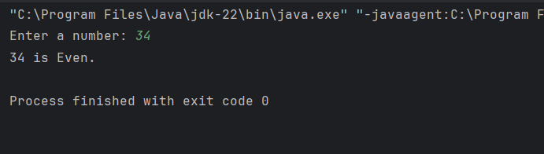
* Write a program that tells whether a given year is a leap year or not.
* 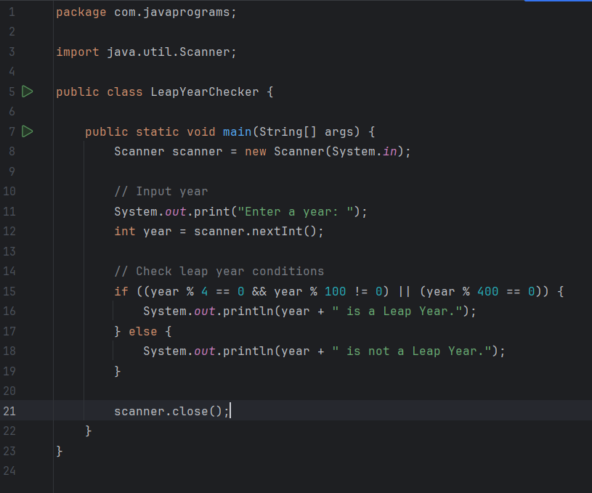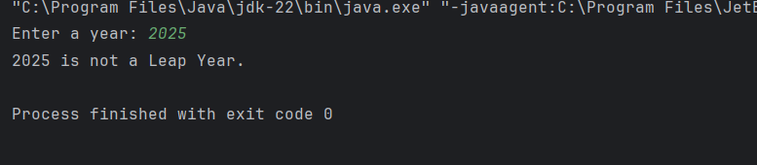
* Write a program that accepts marks of five subjects and finds
* percentage and prints grades according to the following criteria:
  + Between 90-100% ------ Print ‘A’
  + Shape80-90% ------ Print ‘B’
  + Shape60-80% ------ Print ‘C’
  + Below 60% ------ Print ‘D’

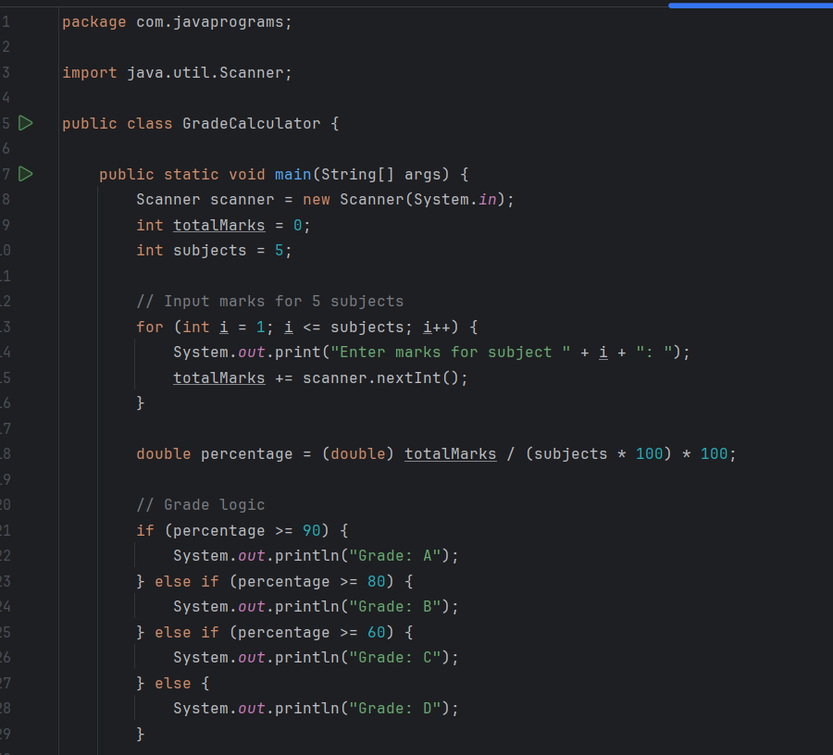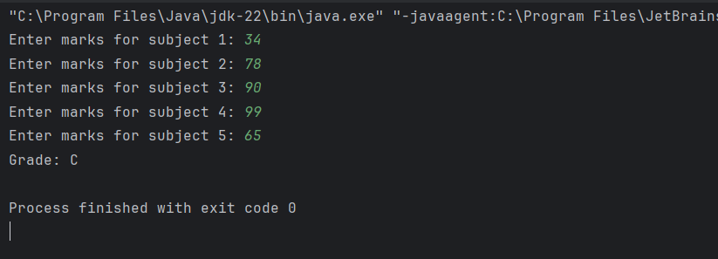

**Points to ponder:**

* **Make an intellij project and keep adding the files for each question.**
* **Try to solve the questions with optimized approach and please explain the approach in comments.**
* **Keep your code readable, modular and follow all the industry accepted naming conventions.**

**For reference please click on the link**

[**Code Conventions for the Java Programming Language: 9. Naming Conventions (oracle.com)**](https://www.oracle.com/java/technologies/javase/codeconventions-namingconventions.html)